Australia’s Prime Ministers 1920s – 1950s

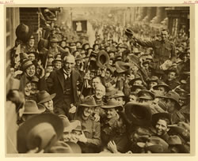

William Morris Hughes: 1915 – 1923

(Australian Labor Party/ Nationalist Party)
William Morris Hughes record term from 1915 to 1923. Replaced Fisher as Prime Minister in 1915 and led Australia during The Great War.
Hughes’ campaign for conscription split the Labor Party and affected political alignment in Australia for the next half century.
Instrumental in the international recognition of Australia as an independent nation through its membership of the League of Nations.
Hughes lost office in February 1923, but served in parliament for three decades more.

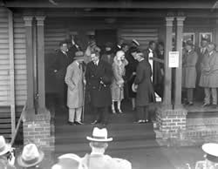
Stanley Melbourne Bruce: 1923 – 1929

(Nationalist Party)
Australia’s eighth Prime Minister is also the second youngest. A decorated war hero before he became Prime Minister in 1923.
His government sought management of imperial trade in Australia’s interests and a voice for Australia in shaping British foreign policy.
His uncompromising stand on industrial relations brought down his government in 1929.
The first tenants of the official prime ministerial residence in the new capital city, the Bruces left their mark on the form and style of The Lodge.

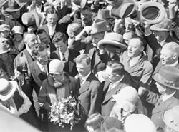
James Scullin: 1929 – 1932

(Australian Labor Party)
James Scullin were given a triumphal welcome on 21 October 1929. Australia’s ninth Prime Minister was unlucky in his timing.
The New York Stock Exchange failure – the ‘Wall Street Crash’ – took place in the first week of his government.
Faced the crisis of economic depression by attempting to manage a failing economy while implementing Labor reforms.

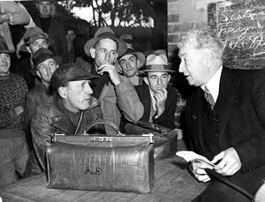
Joseph Lyons: 1932 – 39

(United Australian Party)
Joseph Lyons was the first Australian Prime Minister to die in office.
His cautious and orthodox financial management transformed him from a dissident Labor minister to a conservative Prime Minister.
His Cabinet also needed careful management. He reshuffled ministries several times and negotiated a coalition with the Country Party after the 1934 election.

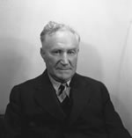

Earle Page: 1939

(Australian Country Party)
Earle Christmas Grafton Page was Prime Minister
for only 20 days, from 7 April 1939 to 26 April 1939. Page was also deputy Prime Minister to SM Bruce in 1923–29, and to Joseph Lyons in 1934–39.
A founder of the Country Party, Page led the party in parliament from 1921 to 1939. He is also remembered for his long term as Minister for Health, from 1949–56, in the government of Robert Menzies.
Though Prime Minister for only three weeks in 1939, Dr Earle Page was deputy Prime Minister for six years from 1923 to 1929.

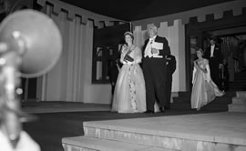
Robert Menzies: 1939 – 1941

(United Australian Party)
Robert Gordon Menzies was Australia’s longest serving Prime Minister.
He held the office twice, from 1939 to 1941 and from 1949 to 1966. Altogether he was Prime Minister for over 18 years – still the record term for an Australian Prime Minister.
Menzies was Prime Minister when World War II began in 1939. In 1941 he lost the confidence of members of Cabinet and his party and was forced to resign.
As an Opposition backbencher during the war years, he helped create the Liberal Party and became Leader of the Opposition in 1946.
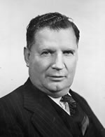

Arthur Fadden: 1941

(Country Party)
Arthur Fadden was Prime Minister from 29 August to 7 October 1941. As well as his ‘40 days and 40 nights’ in office,
he was acting Prime Minister for periods totalling nearly two years during his coalition governments with Prime Minister Robert Menzies.

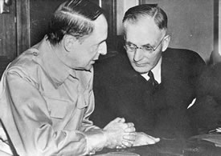
John Curtin: 1941 – 1945

(Labor Party)
Australia’s 14th Prime Minister is widely regarded as one of the greatest. John Curtin’s achievement rests on his leadership of the nation during much of World War II.
Curtin’s rejection of the British strategy for Australian troops enabled the successful defence of New Guinea.
In a remarkable move, he put US General Douglas MacArthur in charge of Australia’s defence forces.
Although he had been a strong opponent of conscription during World War I, as leader during the 1939–45 conflict, Curtin made the decision to send conscripted troops to serve outside Australia.
Curtin was also intent on ensuring that Australia emerge from the war free from the unemployment problems of the 1930s. He aimed for a policy of work for all who wanted it, arguing this could be achieved in peacetime as it had in war. John Curtin died in office, on 5 July 1945, just six weeks before the end of the war in the Pacific.

Francis Forde: 1945

(Australian Labor Party)
Frank Forde was Prime Minister for only eight days, 6–13 July 1945, after the death of John Curtin.
For 14 years he was deputy leader of the federal parliamentary Labor Party, and for nine of those years was deputy Leader of the Opposition.

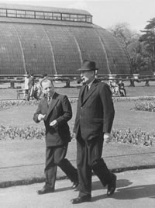
Ben Chifley: 1945 – 1949

(Australian Labor Party)
Chifley was Treasurer in the Curtin Labor government in 1941 and was a prime mover of the economic organisation for the war.
Chifley was elected leader of the Labor Party after John Curtin died in July 1945.
As Prime Minister he introduced national projects such as the Snowy Mountains hydro-electric scheme and the assisted immigration program. He also pushed through legislation that enabled the Commonwealth to become the collector of income tax and sought nationalisation of the private banks so that the federal government could have more control over the economy.
Chifley lost office at the 1949 federal election, after his attempt to nationalise the banks.
In Opposition, Chifley was against RG Menzies’ proposal to ban the Communist Party – a major issue at the federal election of April 1951.

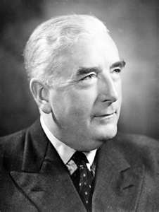
Robert Menzies: 1949 – 1966

(Liberal Party of Australia)
As an Opposition backbencher during the war years, he helped create the Liberal Party and became Leader of the Opposition in 1946.
At the 1949 federal election, he defeated Ben Chifley’s Labor Party and became Australia’s Prime Minister for the second time, laying the foundations for 22 consecutive years in government for the Liberal–Country Party Coalition.
Menzies was often characterised as an extreme monarchist and ‘British to his bootstraps’, but as Prime Minister he maintained Australia’s strong defence alliance with the United States.
During his second period in office the ANZUS and SEATO treaties were signed, Australian troops were sent to support US-led forces in Korea, and Australia made its first commitment of combat forces to Vietnam.
Menzies retired as Prime Minister and from parliament in 1966.

